Activity 4.5: Computer game level up
Program a computer game where you collect gemstones. Each gemstone is worth 50 experience points (XPs). The program should:
- ask the user how many experience points (XPs) they started with
- ask the user how many gemstones they collected
- calculate how many XPs they got from collecting the gemstones
- add the number of XPs they got from collecting the gemstones to the number of XPs they started with
- check to see if the total is more than 1000
- if the total is more than 1000, say Well done you have levelled up!
- if the total is not more than 1000, say You didn’t get enough experience points to level up. Sorry!
For example:
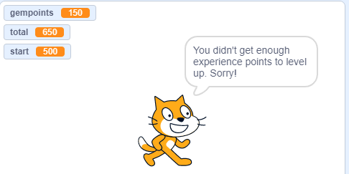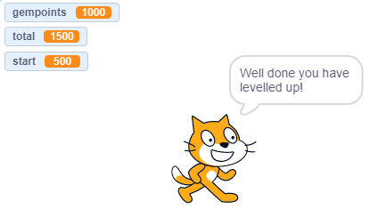
Number of XPs at the start = 500
Gemstones collected = 3
Total XP points = 500 + (3 * 50) = 650
Not enough points to level up
Number of XPs at the start = 500
Gemstones collected = 20
Total XP points = 500 + (20 * 50) = 1500
Enough points to level up

Don’t forget to screenshot your blocks and paste the screenshot into your evidence document.

Extension activity 1
Improve your program so that, if the user does not have enough points to level up, it tells them how many points they need. You will need to:
● calculate how many points they need. This is done by subtracting the total number of points from 1000
● add the number of points they need into the message that says they didn’t get enough points to level up.
For example:
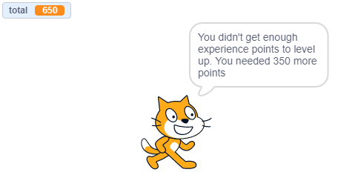

Remember to screenshot your blocks and paste the screenshot into your evidence document.

Extension activity 2
The game has been updated so that you can level up twice. To level up twice, you need to collect a total of more than 2000 XP points. If you don’t get more than 2000 points, you can still level up once with 1000 points.
For example:
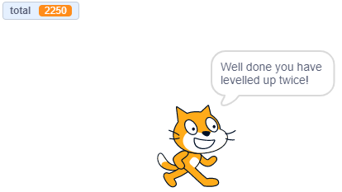

HINT: You will need to nest an if-else statement inside an if-else statement, so you can check more than one condition. Here is an example of how to do this:
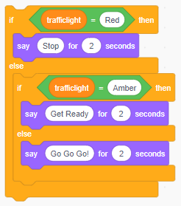

Remember to screenshot your blocks and paste the screenshot into your evidence document.

